PortSwigger Lab POC - 06-username-enumeration-account-lock

Lab 6 — Username enumeration via account lock

Step 1 — Login with random credentials
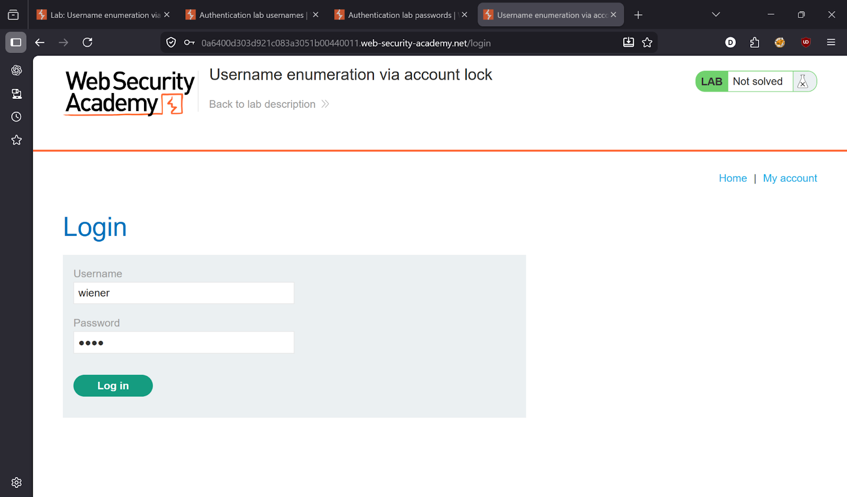

---

Step 2 — Send to Intruder
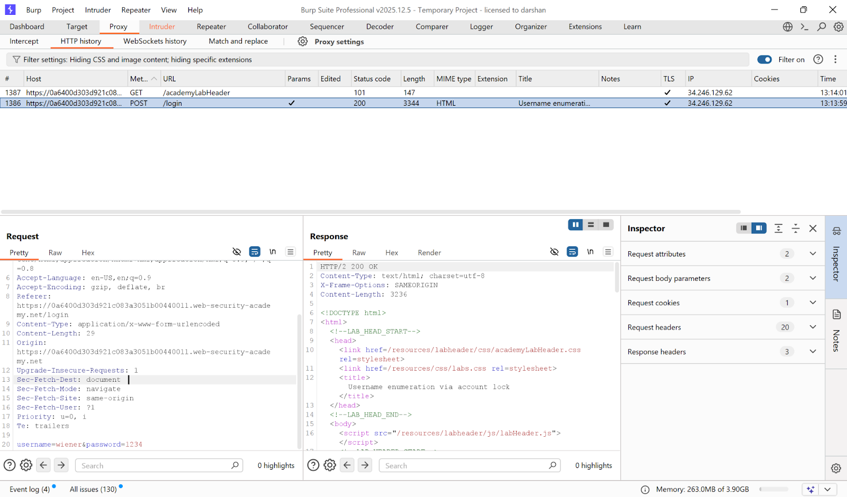

---

Step 3 — Cluster Bomb attack
- Payload 1: username wordlist
- Payload 2: null payload × 5 (sends each username 5 times)

Valid accounts get locked → different response.

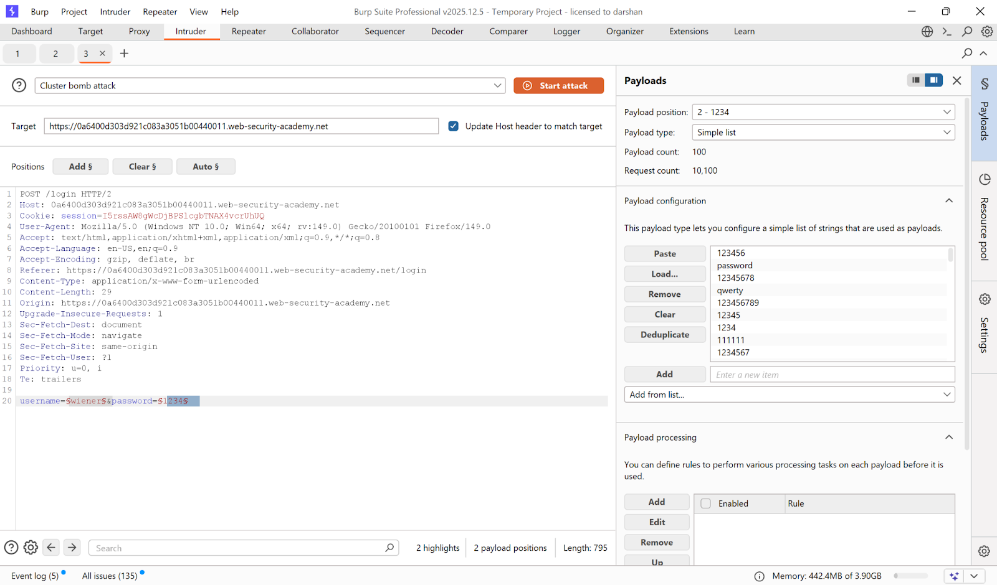
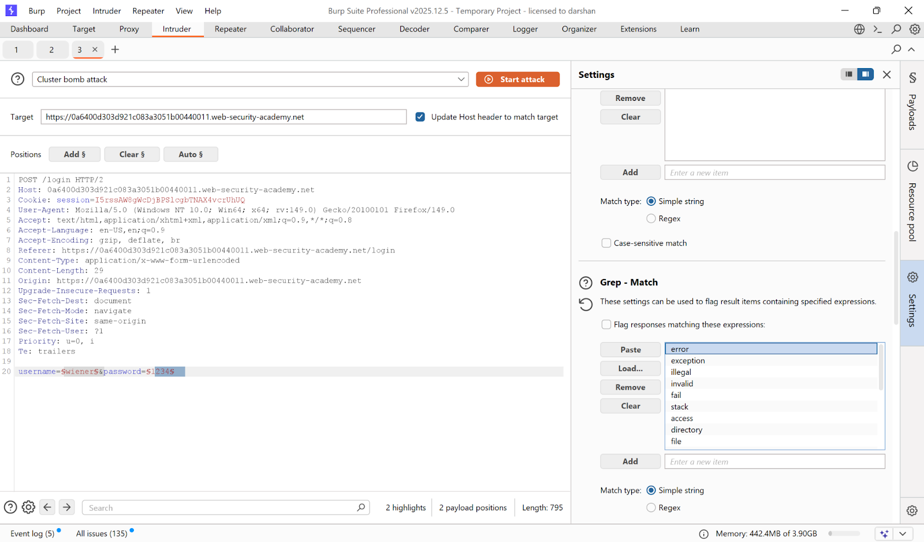

---

Step 4 — Find locked account
Response with lockout message = valid username.

**Found username: `agent`**

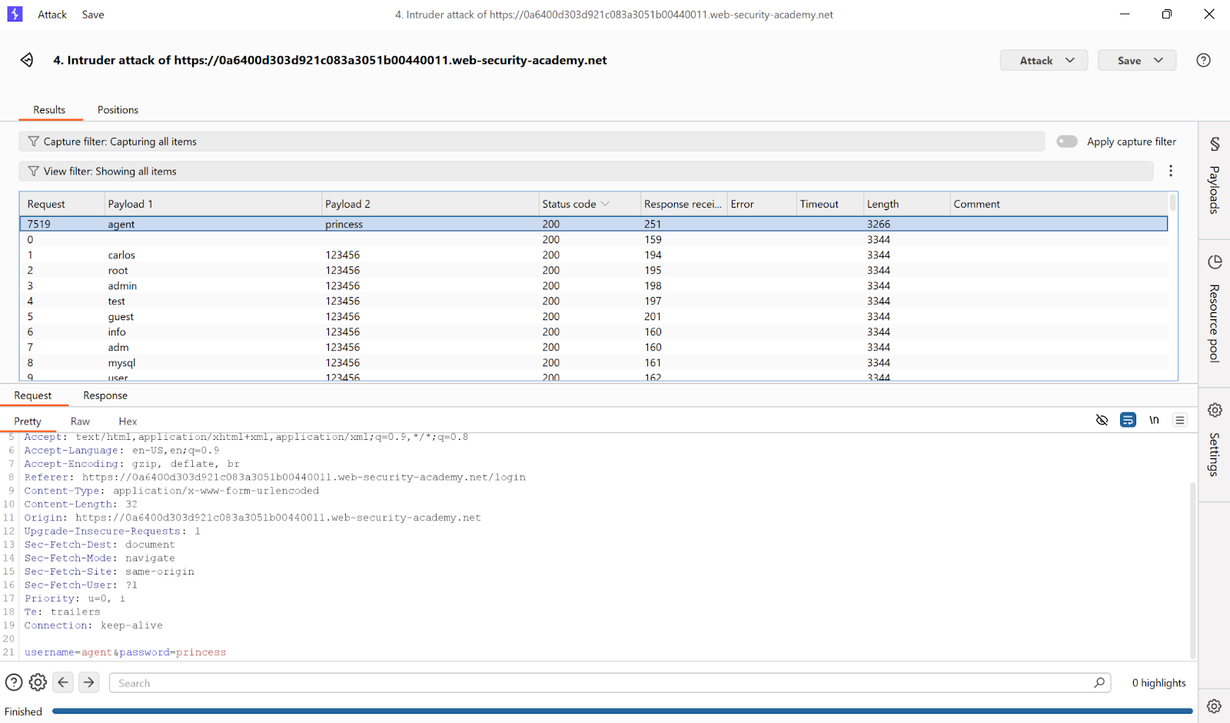

---

Step 5 — Login as victim
Wait ~1 minute, then brute-force password.

**Password: `princess`**

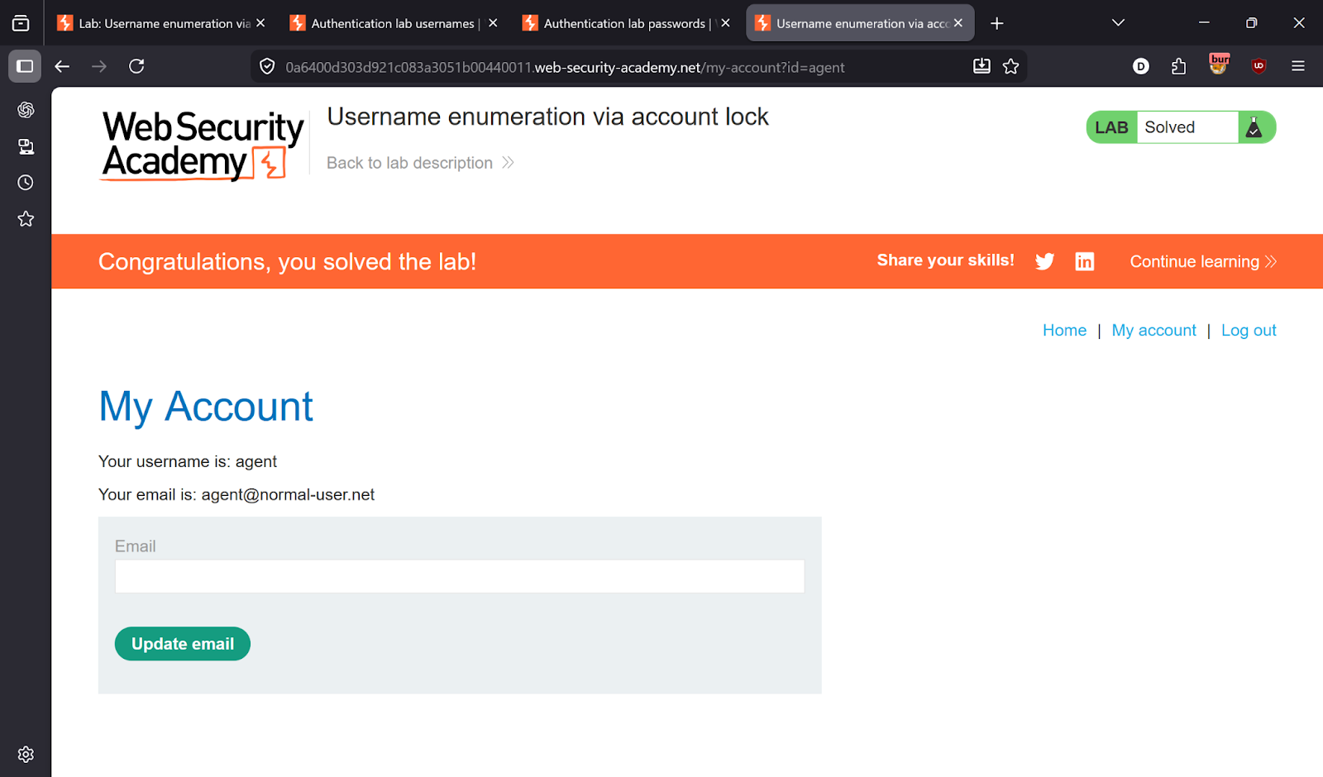

---

✅ Result
- **Username:** `agent`
- **Password:** `princess`

